Request to all to use the following YouTube Playlist for this course:
https://www.youtube.com/playlist?list=PL5WPb1PlL9BT9_ugd5vkVEeQfMaoDD-qf

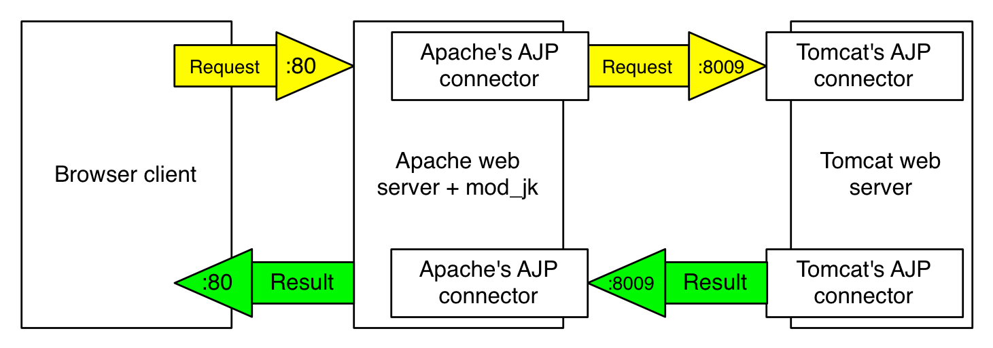

Login to VPS using Putty:

Download Java jdk-9:
http://www.oracle.com/technetwork/java/javase/downloads/jdk9-downloads-3848520.html
Java:
/usr/java/jdk-9.0.1

Set Java Home and Path:
vi ~/.bash_profile
export JAVA_HOME=/usr/java/jdk-9.0.1/
export PATH=$JAVA_HOME/bin:$PATH

Tomcat 8.5.6:
https://tomcat.apache.org/download-80.cgi

Tomcat Path:
/opt/code/apache-tomcat-8.5.6

1. mkdir downloads
2. wget http://redrockdigimark.com/apachemirror/tomcat/tomcat-connectors/jk/tomcat-connectors-1.2.42-src.tar.gz
3. tar -xf tomcat-connectors-1.2.42-src.tar.gz
4. cd tomcat-connectors-1.2.42-src/native/
5. ./configure --with-apxs=/usr/local/apache/bin/apxs

If you get an error like below,
“configure: error: Invalid location for apxs: '/usr/local/apache/bin/apxs'”
Follow the steps below steps,
yum install apr-devel
yum install apr-util-devel
yum install pcre
yum install pcre-devel
cd /usr/src
wget http://mirror.lax.hugeserver.com/apache/apr/apr-1.6.3.tar.gz
wget http://mirror.lax.hugeserver.com/apache/apr/apr-util-1.6.1.tar.gz
tar -xf apr-1.6.3.tar.gz
tar -xf apr-util-1.6.1.tar.gz
cd apr-1.6.3
./configure --bindir=/usr/bin/
make
make install
cd ..
cd apr-util-1.6.1
./configure --bindir=/usr/bin --with-apr=/usr/bin/apr-1-config
make
make install
cd ..
wget http://redrockdigimark.com/apachemirror//httpd/httpd-2.4.28.tar.gz
tar -xf httpd-2.4.28.tar.gz
cd httpd-2.4.28
./configure --prefix=/usr/local/apache --enable-rewrite=shared --enable-proxy=shared
make
make install

6. make
7. make install

8. cd /usr/local/apache/modules
9. cd /usr/local/apache/conf
10. vim workers.properties

worker.list=upyourcode

worker.upyourcode.type=ajp13
worker.upyourcode.port=8009
worker.upyourcode.host=192.169.217.121

11. Apache Web Server file:
vim /usr/local/apache/conf/httpd.conf

LoadModule jk_module modules/mod_jk.so

JkWorkersFile /usr/local/apache/conf/workers.properties

JkLogFile logs/mod_jk.log
JkLogLevel emerg
JkLogStampFormat "[%a %b %d %H:%M:%S %Y] "
JkOptions +ForwardKeySize +ForwardURICompat -ForwardDirectories
JkRequestLogFormat "%w %V %T %p %q %r %v %U"

<VirtualHost *:80>
ServerName www.upyourcode.com
RewriteEngine on
RewriteRule ^/(.*)$ /upyourcode/$1 [L,PT]
JkMount /* upyourcode
</VirtualHost>

12. service httpd stop
service httpd start

